**Automatic Brain Tumour Segmentation Using Image Processing**

## Name : Zubair Idrees

## ID : 197301

## Submitting to Respected DR. Ahsan

*Abstract*---Brain tumour is a mass or growth of abnormal cells in your brain. Diagnosis of the Brain tumours is happening using manual visualizing & segmentation of the Brain MRI scans & that is difficult tasks & also sometime experts can miss the small tumours by manually analysing the MRI scan. In this paper, using various image processing algorithm includes image processing, enhancement, segmentation, feature extraction and classification, patient MRI scan images will be analysed & Detection the tumour size, shape, and location will be happened. It will be helpful for the experts to early detect even small size of the tumours to reduce the later on risk & effects.

# INTRODUCTION

One of the key causes of the rise in mortality among children and adults is brain tumours. Brain tumour is an unusual growth of tissues of abnormal cells in brain. There are two stages of the brain Tumour.

1) Primary stage

2) Secondary stage

Primary brain tumours are tumours which originate from brain cells or brain covers.

A secondary or metastatic brain tumour develops when the cells of the cancer migrate into the brain in another region of the body from primary cancer. Glioblastoma is one of the most aggressive and fatal human brain tumours **(1).** There are several heterogeneous histological subregions containing Gliomas, including peritumour edema, necrotic heart, enhancement and non-enhancement of tumour core.

In radiology, magnetic resonance imaging (MRI) is widely used to reflect the phenotype and intrinsic heterogeneity of gliomas, as multimodal MRI scans, such as T1-weighted, T1-weighted contrast enhanced (T1Gd), T2-weighted, and FLAIR (Fluid Attenuation Inversion Recovery) images, provide complementary profiles for different glioma sub-regions.

The enhancing tumour sub-region, for example, is identified by areas that, compared to a T1 scan, display hyper-intensity in a T1Gd scan. Accurate and robust predictions of overall survival, using automated algorithms, for patients diagnosed with gliomas can provide valuable guidance for diagnosis, treatment planning, and outcome prediction **(2)**. It is difficult, however, to pick accurate and potent prognostic characteristics. Medical imaging (e.g., MRI, CT) can provide radiographic phenotype of tumour, and it has been exploited to extract and analyse quantitative imaging features **(3).** Clinical data may also provide useful information on the outcome of patients, including patient age and resection status.

In this paper, by filtering and cleaning up the MRI scan, via binarization, median, filtering, and sliding windows, we will define the methods for image analysis. Next, it will teach how to use a pre-generated elliptical mask to isolate the tumour and further filter it to outline the perimeter of the tumour’s form.

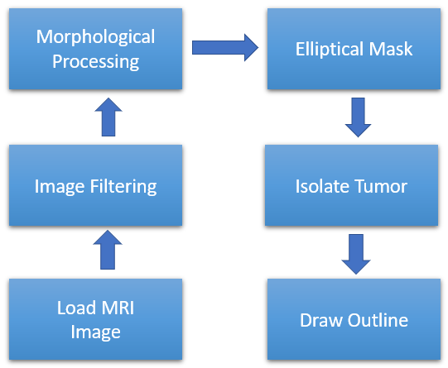

Fig. 1. Shows the process of tumour detection.

1. *RELATED WORK*

This section deals with the works related to the use of medical image processing in the brain tumor detection. Generally, many researches and studies were done in the area of image processing by using different techniques. And depending on the problem posed, the researcher chose the right method. A number of approaches have been used to extract the brain tumor based on MRI technique, segment and predict its grade and volume. Nerurkar in his work **[4]** proposed a segmentation study to extract the brain abnormalities in MRI images. The results of the two efficient image segmentation algorithms presented in **[5]** i.e. K-means and region growing techniques let the author to select the best one. Carlos, Khan and Robert, in their work **[6]** suggested an ameliorated artificial neural network algorithm to perform segmentation of brain MRI and to be used for segmentation. Their result suggests excellent brain tissue segmentation. Some of other related works discussed the idea of MRI medical Image denoising by fundamental filters such as Median filter (MF), Adaptive Median filter (AMF) and Adaptive Wiener filter (AWF). Then, the performance of these filters will be compared in **[5].** In our work, as first part, an improved comparative study between three types of filter is implemented to remove diverse kind of noise. This make us to continue the next part which is detection of brain tumor based on the morphological operation by using the best filter.

# *Proposed Methodology*

# **Loading and Reading MRI Images**

The images are read using the built-in 'dicomread' MATLAB function. The built-in 'dicominfo' MATLAB function is also extremely useful in addressing all the data of each MRI dicom file. We used this feature to extract all of the patients' descriptive details, such as their sex, age, weight, and height.

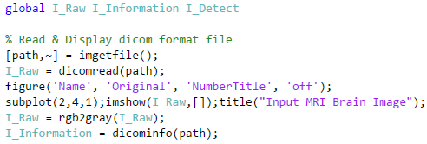

# **Image Filtering**

After the raw image DICOM file has been loaded and read, the image needs to be transformed from grayscale to a binarized form consisting only of black and white pixels. We used the 'imbinarize' method to construct a raw image binary image by manipulating adaptive thresholding elements at a sensitivity value of 0.59.

The default sensitivity threshold factor, 0.5, was lower and the image did not identify the brighter blobs and spots, so we increased it to 0.59. Since the binarized image is two-dimensional, the binarized image is then processed using the 'medfilt2' function via a 5x5 median filter.

This eliminates the noise and maintains the edges around each pixel in a 5 x 5 square.

Next, to construct a disk-shaped flat structuring feature with a neighbourhood radius of 2 to define each central, original pixel in each disk neighbourhood, we apply a sliding window using 'strel'. We used a disk structuring feature since we examine each circular spot and the pixels inside each spot, which is more useful for the disk shape feature. When the image has been filtered, it can be cleaned to eliminate the black spots between the filtered white pixels in the image and close all the gaps around it using the 'imclose' feature.

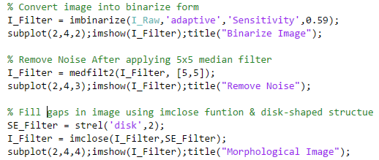

# **Tumour Isolation**

Through a pre-generated elliptical mask, the bright spots of the tumour can then be separated from the main filtered image.

After considering the size of the original, raw MRI scan image to construct this mask, and assign the centre coordinates to the elliptical using its row and column length, as x and y- co-ordinates, respectively. The y-axis is set as a main axis with a radius of 30 units from the centre and a radius of 20 units from the centre as the minor axis. To create a Cartesian plane with two-dimensional grid coordinates centered on the coordinates contained in vectors from 1 to the length of the x-axis and from 1 to the length of the y-axis of the image, we used the MATLAB' meshgrid 'feature. Col is a matrix in which the x-axis is copied by each row, and Row is a matrix in which the y-axis is copied by each column. The Cartesian grid represented by the Col and Row coordinates has columns of length (1: Y Size) rows and length (1: X Size). To determine the ellipse equation based on the predetermined radius and centre coordinates, use the indices of Col and Row provided by the Cartesian grid. It is now possible to fill the elliptical

outline with the white pixels present in tumour spots. We can cut out the particular tumour that want to examine from the filtered image using the pre-generated elliptical mask. The elliptical mask detects which spots match logically within the ellipse outline and accepts this as a spot to be appropriate as a tumour on the filtered image. The 'bwareafilt' feature then filters out all other artifacts from the image outside of this detected tumour. Based on the dimensions of all the images, we used a particular window of 700 by 4000 empirically. Then, as a flat disk-shaped structuring factor of a greater neighbourhood radius of 6, we applied

another sliding window with 'strel' to close the gaps inside the detected tumour between each central white pixel. The tumour spot found is further cleaned up using 'imclose'.

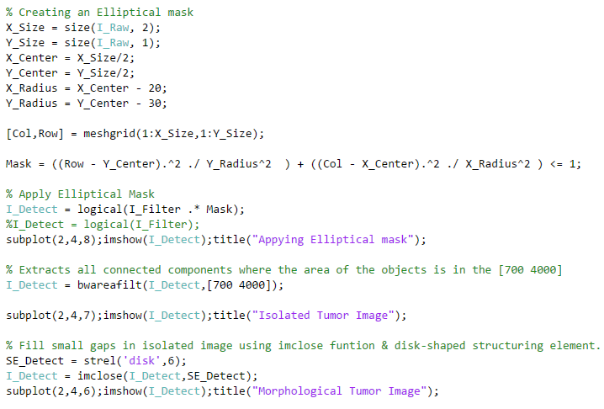

# **Tumour Outlining**

Now that the tumour is isolated by the mask, to show its exact position, it can be outlined and viewed in the original image.

We used the 'bwboundaries' feature to trace the previously observed tumour with an outline to do this. As it is being outlined, we specified the outline not to include the holes inside the tumour piece.

Using a 'for' loop that plots the outline around the tumour using the line indices with a line width of 1.5 pixels, this can be plotted on to the original, raw image. On the raw image, this outline is then plotted, showing the exact size and location of the tumour compared to the initial MRI scan.

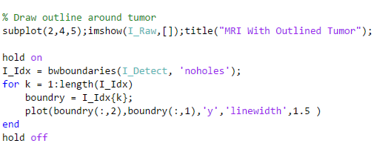

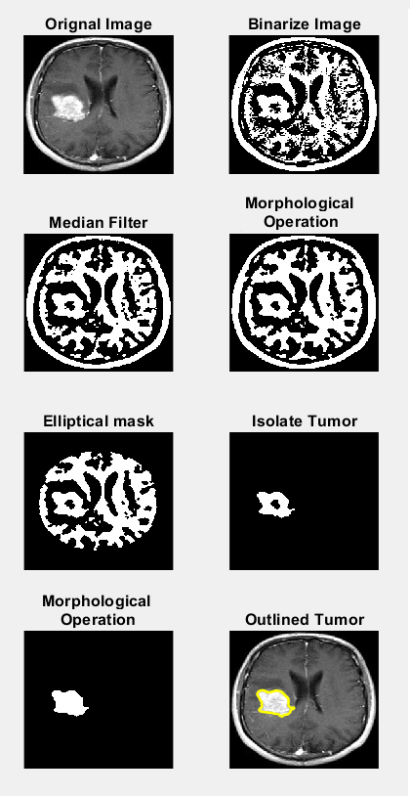

Fig. 2 shows the output images after each process

1. *Conclusion*

This thesis has been written by an MRI brain tumour prediction algorithm using MATLAB software. Selecting the right filters and methods would improve our algorithm relative to regular algorithms. Picture analysis, on the other hand, is a process in which the picture is analysed and processed intensively and is one of the key points of the document. This work will make the MRI image processing and tumour detection process quicker and cheaper for optimum tumour detection solution using elliptical filters and morphological operators. As result, it can be easier on modern medicine extraction tumour. The algorithm that has been developed can be improved in the next work by including more details on tumour prediction before detection.

# **References**

1. Bleeker, F. E., Molenaar, R. J., and Leenstra, S. (2012). Recent advances in the molecular understanding of glioblastoma. *J. Neuro Oncol.* 108, 11–27. doi: 10.1007/s11060-011-0793-0
2. Liu, L., Zhang, H., Wu, J., Yu, Z., Chen, X., Rekik, I., et al. (2018). Overall survival time prediction for high-grade glioma patients based on large-scale brain functional networks. *Brain Imaging Behav*. 1–19. doi: 10.1007/s11682-018-9949-2
3. Gillies, R. J., Kinahan, P. E., and Hricak, H. (2016). Radiomics: images are more than pictures, they are data. *Radiology* 278, 563–577. doi: 10.1148/radiol.2015151169
4. S. Nerurkar, Brain tumor detection using image segmentation, International Journal of Engineering Research in Computer Science and Engineering ,4, 65- 70 (2017)
5. A. v. Opbroek, M. A. Ikram, M W. Vernooij, M. Bruijne, Transfer Learning Improves Supervised Image Segmentation Across Imaging Protocols, IEEE Transactions on Medical Imaging, 34, 1018-1030 (2014)
6. P. Carlos, I. Khan, K. Robert, Automated brain data segmentation and Pattern recognition using ANN, Proc. CIRAS, 2003